Numeric Precision Issures in SAS

Accompany to Programming_Tips_v2-2 by Shekar

All the binary arithmetic you need to know and no more…

John (Jiangtang) Hu
Biostatistics China, sanofi pasteur
jiangtang.hu@sanofipasteur.com

May 8, 2009

- Overview of Numeric Systems: Decimal, Binary and Hexadecimal

  - Decimal System

We use decimal numbers as our default numeral system. For example, she has 10 fingers and 100 diamond rings. Decimal system uses 10 as its base (Because Ten is the number which is the count of fingers on both hands?).

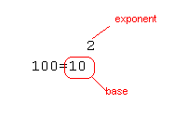

In precise way, 100 is calculated as follows in decimal system:

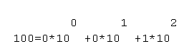
The above expression is related the counting process of any numeral system. Beginning with a single digit, counting proceeds through each symbol (0 through 9) in increasing order.

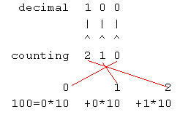
We can define more about the basic parts of the scientific notation:

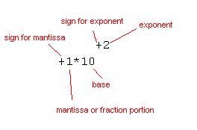
Numbers in scientific notation are comprised of the following parts:

The base is the number raised to a power; in this example, the base is 10.

The mantissa is the number multiplied by the base; in this example, the mantissa is 1.

The exponent is the power to which the base is raised; in this example, the exponent is 2.

For more, see
http://en.wikipedia.org/wiki/Decimal

  - Binary System

Binary numbers are more common in computational world. Binary system has only two symbols (0, 1) and is equivalent to sums of powers of 2 in the decimal system.

For more, see
http://en.wikipedia.org/wiki/Binary_numeral_system

    - Decimal numbers to Binary numbers

To convert from a base-10 integer numeral to its base-2 (binary) equivalent, the number is divided by two, and the remainder is the least-significant bit. The (integer) result is again divided by two, its remainder is the next most significant bit. This process repeats until the result of further division becomes zero. For example, Decimal 10= Binary 1010

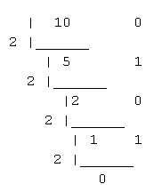
Or, you can convert decimal numbers to binary numbers using the following SAS codes:

data _null_;
x1=10;
x2=put(x1, binary4.);
put x1= '(decimal)' ;
put x2= '(binary)';
run;

The output is:

Equivalently,

data _null_;
x=10;
put x= binary4.;
run;

    - Binary numbers to Decimal numbers

Similar to the counting procedure of decimal system mentioned above: beginning with a single digit, counting proceeds through each symbol (0 and 1, other than 0 through 9 in decimal system) in increasing order.

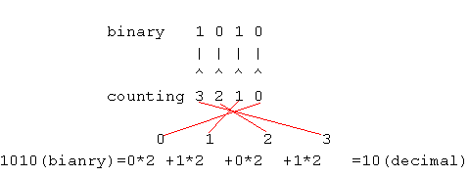

Or, you can convert binary numbers to decimal numbers using the following SAS codes:

data _null_;
y1='1010';
y2=input(y1,binary4.);
put y1= '(bianry)';
put y2= '(decimal)';
run;

The output is: Hexadecimal

  - Hexadecimal System

Hexadecimal (Hex) is a numeric system with a base of 16. It uses sixteen symbols, 0–9 to represent values zero to nine, and A, B, C, D, E, F to represent values ten to fifteen.

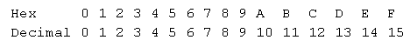
For more, see

http://en.wikipedia.org/wiki/Hexadecimal

    - Decimal numbers to Hexadecimal numbers
Ee

data _null_;
x1=100;
x2=put(x1, hex2.);
put x1= '(decimal)' ;
put x2= '(hex)';
run;

The output is:

    - Hexadecimal numbers to Decimal numbers

Numeric Constants Expressed in Hexadecimal Notation, 64x

data _null_;
y1=64x;
put y1= hex2.'(hex)';
put y1= best12. '(decimal)';
run;

The output is:

Character Constants Expressed in Hexadecimal Notation ‘64’x

data _null_;
y1='64';
y2=input(y1,hex2.);
put y1= '(hex)';
put y2= '(decimal)';
run;

The output is as same as the above.

- SAS and numeric system:

Significant Digits and Largest Integer by Length for SAS Variables under UNIX

